WEB APPLICATION PENETRATION TESTING

Access Control Assessment Report
User Role Controlled by Request Parameter
Platform: PortSwigger Web Security Academy | Tool: Burp Suite Community Edition

1. Summary
This assessment tested the PortSwigger lab “User role controlled by request parameter”. The application used a client-side cookie named Admin to determine whether the user had administrative access. By changing the cookie value from false to true, the regular wiener account was able to access the admin panel and perform an administrative action. The lab displayed its success confirmation.

2. Objective and Scope
Objective: determine whether the application relies on a user-controlled request cookie to make authorization decisions.
Scope: the intentionally vulnerable PortSwigger Web Security Academy lab environment. The findings describe this lab only.

3. Method
- Logged in to the lab as the regular user wiener.
- Inspected the authenticated request and identified the Admin cookie set to false.
- Changed the Admin cookie value to true in the browser.
- Accessed the admin panel while using the regular user session.
- Used the admin panel to delete the carlos account and confirmed that the lab was solved.

4. Finding
The application trusted a client-controlled Admin cookie to determine the user's role. Because the browser could modify this value, a regular user could change it to true and gain access to administrative functionality.
Authorization decisions must be enforced on the server using trusted session or identity data. A client-side cookie value must not be treated as proof of administrative privilege.

5. Evidence
Screenshots are arranged chronologically. The session identifier is redacted where it appears; the Admin cookie value remains visible because it is relevant to the finding.
Figure 1 — Authenticated request as wiener
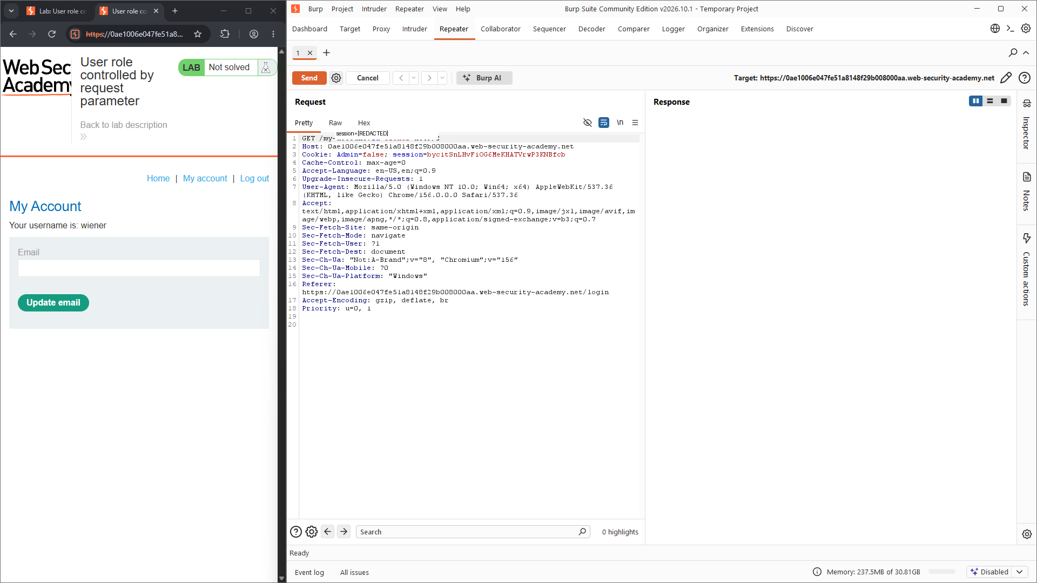
The request is made as the regular user and includes the Admin=false cookie.
Figure 2 — Admin cookie before modification
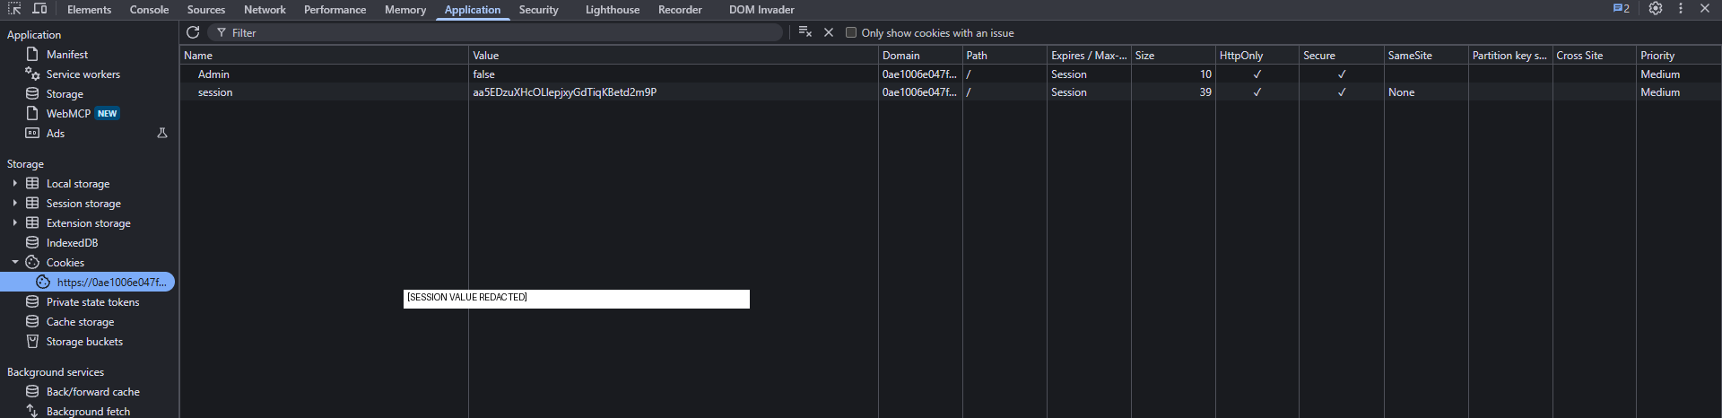
Browser storage shows the Admin cookie set to false.
Figure 3 — Admin cookie after modification
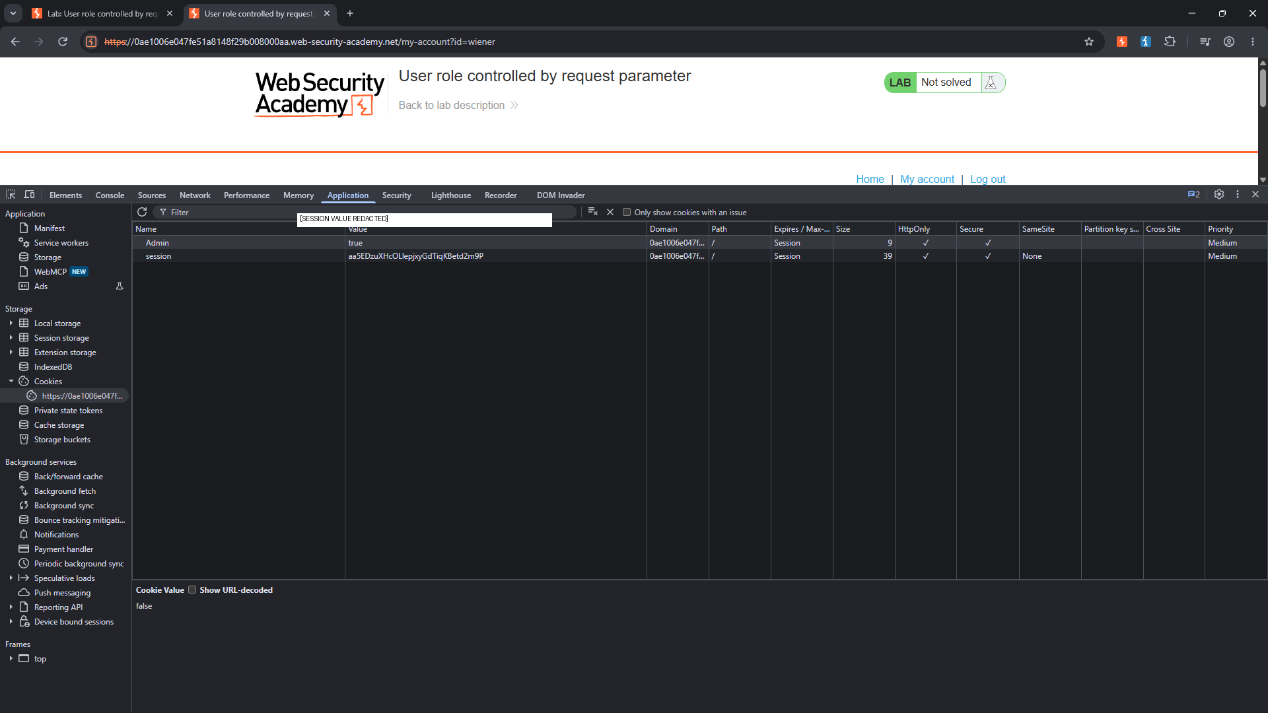
The Admin cookie is changed to true in the browser.
Figure 4 — Access to the admin panel
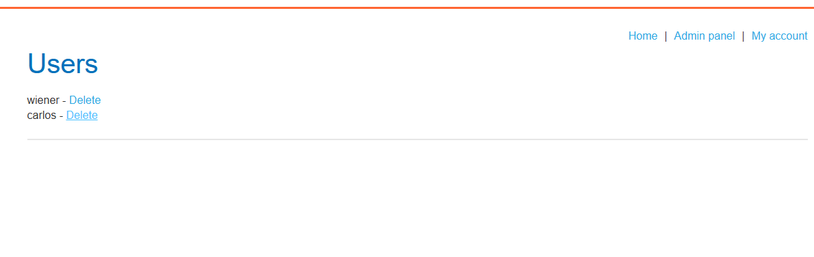
The admin panel is accessible and lists the wiener and carlos accounts.
Figure 5 — Administrative action
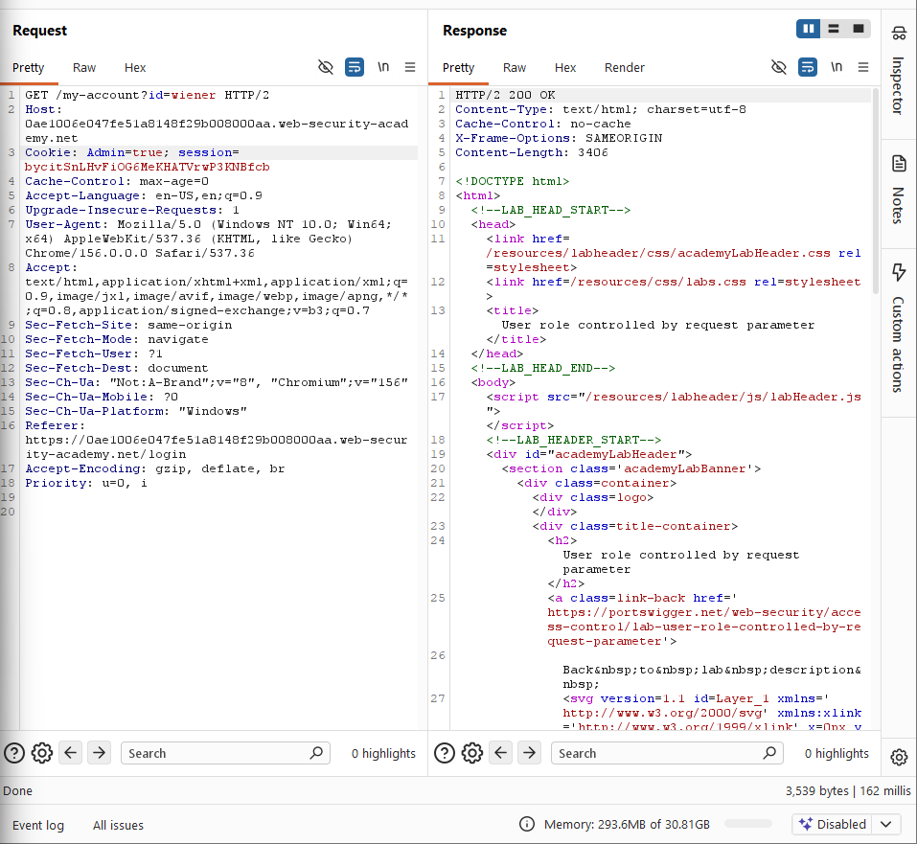
The interface confirms that the carlos user was deleted successfully.
Figure 6 — Lab completion
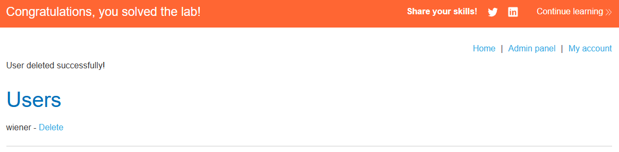
PortSwigger displays the lab success confirmation.

6. Impact
A user with a normal account could gain administrative access by modifying a client-side role indicator. Depending on the administrative functions available, this may allow unauthorised access to sensitive information or modification and deletion of other users' accounts. The lab evidence confirms access to the admin panel and deletion of the carlos account.

7. Severity
CVSS v3.1: 8.1 — High (indicative)
Vector: CVSS:3.1/AV:N/AC:L/PR:L/UI:N/S:U/C:H/I:H/A:N
This indicative score assumes an authenticated low-privilege user can remotely obtain administrative access, with high confidentiality and integrity impact. Availability impact is not included in this vector. A real deployment must be scored against its actual administrative capabilities and business impact.

8. Recommendations
- Do not store or trust authorization roles in client-controlled cookies.
- Enforce role and permission checks on the server for every administrative request.
- Derive privileges from trusted server-side session data or a verified identity provider.
- Apply least-privilege access and deny administrative actions by default.
- Log and monitor attempts to access administrative endpoints without the required role.

9. Conclusion
The lab demonstrated vertical privilege escalation caused by trusting a modifiable Admin cookie. Server-side authorization checks are required to ensure that only appropriately privileged users can access administrative functionality.

Reference
PortSwigger Web Security Academy — User role controlled by request parameter:
https://portswigger.net/web-security/access-control/lab-user-role-controlled-by-request-parameter

Disclaimer
This assessment was conducted in an intentionally vulnerable PortSwigger training environment. Testing must only be performed against systems for which explicit authorisation has been obtained.

